
 | ST.ANN’S COLLEGE FOR WOMEN  Run by the Society of St. Anne, A Catholic Christian Minority Institution  Affiliated to Acharya Nagarjuna University, Approved by AICTE  Recognised under 2(f) of UGC Act 1956, New Delhi  Accredited by NAAC with “A “ Grade in the First Cycle  AMARAVATHI ROAD , GORANTLA, GUNTUR – 522034, A. P  Email: st_anns_coll@yahoo.co.in Website: www.stannscollegeforwomen.org | Criterion:  VI
 |  | Metric :

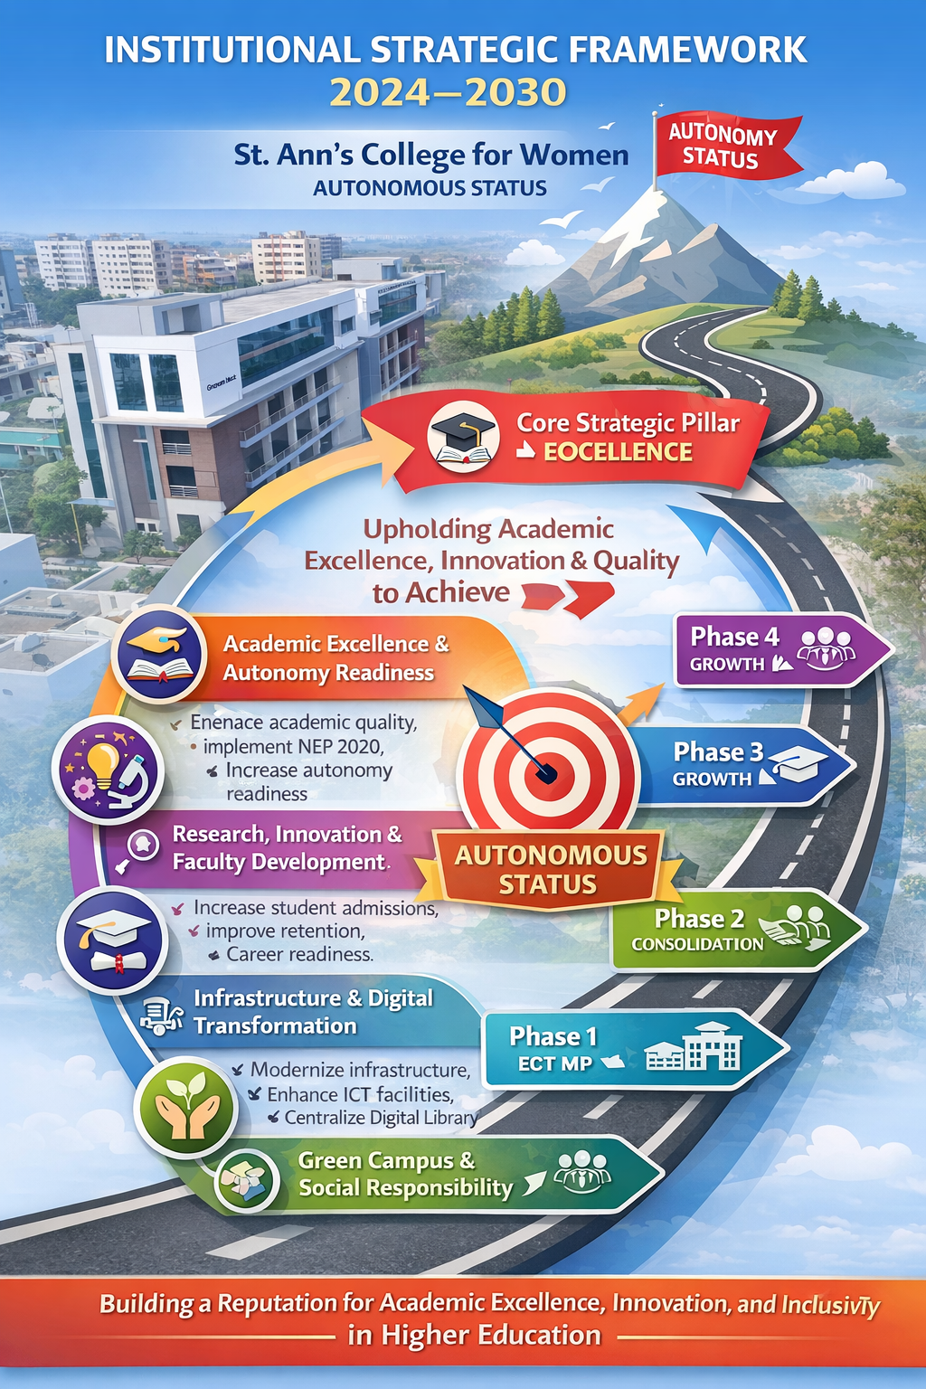
INSTITUTIONAL STRATEGIC FRAMEWORK (2024–2030)
INTRODUCTION
The Strategic Plan of St. Ann’s College is executed through a 4-Level Framework:
I. VISION & MISSION
St. Ann’s College for Women, Gorantla, Guntur
Guided by its enduring motto, “Educate • Enrich • Empower,” St. Ann’s College for Women stands as a beacon of value-based education and women’s empowerment since its establishment in 1997. The institution’s identity is deeply rooted in its emblem, which symbolically represents its educational philosophy through the Candle (Light of Knowledge), the Book (Foundation of Wisdom), and the Lotus (Resilience and Growth). These symbols collectively reflect the College’s commitment to nurturing enlightened, capable, and socially responsible women.
With the inspiring tagline “Where Knowledge Ignites Empowerment,” the institution envisions transforming learners into confident, ethical, and globally competent leaders. The Vision of the College is to emerge as a premier center of academic excellence that integrates value-based education with innovative skills, thereby contributing to the national mission of Viksit Bharat through empowered women leaders.
To realize this vision, the institution is anchored in four core Mission pillars:
Innovative Pedagogy, Character Building, Inclusive Learning Environment, and Skill Integration. These pillars ensure a holistic approach to education that not only emphasizes academic excellence but also fosters moral integrity, inclusivity, and career readiness aligned with national initiatives such as NEP 2020 and Skill India.
The Institutional Objectives further translate this vision into actionable priorities, focusing on academic rigor, digital innovation, mentorship, resilience, economic self-reliance, and civic responsibility. Through these objectives, the College strives to create an ecosystem that promotes critical thinking, lifelong learning, and societal engagement.
A distinctive feature of the institution is its clearly defined Graduate Attributes, which shape the profile of a “St. Ann’s Woman.” Graduates are envisioned as academically proficient, ethically grounded, socially responsible, and entrepreneurially driven individuals who possess strong communication skills, leadership qualities, and the ability to adapt to a rapidly evolving global environment.
Building upon this strong philosophical and academic foundation, the Strategic Perspective Plan (2024–2030) has been developed as a comprehensive roadmap for institutional growth and quality enhancement. The plan is systematically aligned with:
- Institutional Vision and Mission
- SWOC Analysis outcomes
- Recommendations of the NAAC Peer Team (June 2024)
- National priorities such as NEP 2020 and Viksit Bharat
The Strategic Plan focuses on achieving Autonomous Status by 2029–2030, while strengthening key domains such as academic excellence, research culture, student success, infrastructure development, digital transformation, and industry collaboration.
Through a structured framework of long-term goals, annual action plans, and measurable outcomes, the institution ensures effective strategy development, deployment, monitoring, and continuous improvement in line with NAAC quality benchmarks.
In essence, this Strategic Perspective Plan is not merely a policy document but a dynamic blueprint for transformation, reflecting the institution’s unwavering commitment to nurturing empowered women who contribute meaningfully to society and the nation.
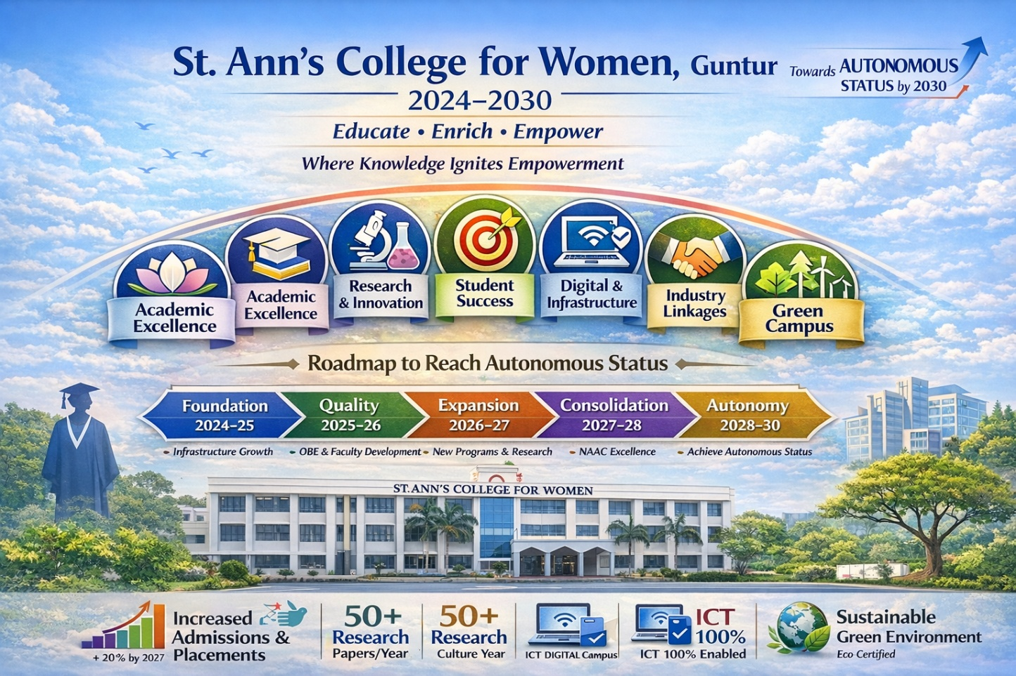
II .ULTIMATE INSTITUTIONAL GOAL & STRATEGIC DIRECTION
St. Ann’s College for Women, Gorantla, envisions achieving Autonomous Status by 2029–2030 through a systematic and transformative approach to institutional development. This vision is driven by a commitment to academic excellence, research advancement, student success, infrastructure modernization, industry integration, environmental responsibility, and robust governance.
To translate this vision into action, the institution has identified seven core strategic pillars that collectively guide its growth and quality enhancement journey:
- Academic Excellence & Autonomy Readiness
- Research, Innovation & Faculty Development
- Student Enrollment, Retention & Success
- Infrastructure & Digital Transformation
- Industry Linkages & Employability
- Green Campus & Social Responsibility
- Governance & Quality Assurance
These pillars form the foundation of the Strategic Perspective Plan (2024–2030), ensuring a structured, measurable, and outcome-driven pathway towards institutional excellence and autonomy.
Core Strategic Pillar 1: Academic Excellence & Autonomy Readiness
(Long-Term Strategic Goal with KPIs: 2024–2030)
Strategic Focus:
To build a robust academic ecosystem aligned with NEP 2020, fostering quality, innovation, and autonomy readiness through outcome-driven education, continuous curriculum enhancement, and sustainable institutional growth.
Key Initiatives:
- Effective implementation of Outcome-Based Education (OBE) across all programmes
- Integration of NEP 2020 principles into curriculum design and delivery
- Introduction of innovative, interdisciplinary, and skill-oriented UG, PG, and Integrated programmes
- Continuous curriculum enrichment aligned with industry and global standards
- Strengthening IQAC-led academic audits and quality assurance mechanisms
- Enhancement of student intake capacity, particularly in emerging and high-demand programmes
- Strategic focus on increasing admissions and student enrollment to ensure financial sustainability and institutional stability
Action Plan:
- Implement OBE framework across all departments
- Introduce 3–5 new academic programmes in emerging disciplines
- Conduct regular academic and administrative audits
- Align teaching-learning processes with student-centric and experiential methodologies
- Launch targeted admission outreach strategies to improve enrollment and optimize institutional resources
Key Performance Indicators (KPIs):
- 100% OBE implementation across all programmes by 2026
- Minimum 5 new programmes introduced by 2028
- Consistent pass percentage of ≥90% across programmes
- Increase in student admissions by 15–20% by 2027
- Improved enrollment in diversified and skill-based programmes
- Enhanced financial sustainability through optimal student strength and resource utilization
Core Strategic Pillar 2: Research, Innovation & Faculty Development
(Long-Term Strategic Goal with KPIs: 2024–2030)
Strategic Focus:
To establish a dynamic research and innovation ecosystem that enhances faculty competencies, promotes knowledge creation, and strengthens the institution’s academic reputation in alignment with NAAC quality benchmarks.
Key Initiatives:
- Establishment of a Research & Innovation Cell to promote a research culture
- Enhancement of faculty qualifications, with a focus on increasing Ph.D. holders
- Promotion of quality research publications in reputed national and international journals
- Provision of seed funding, research incentives, and support mechanisms
- Organization of National and International Conferences, Seminars, and Workshops
- Encouragement of interdisciplinary and collaborative research initiatives
Action Plan:
- Establish and operationalize the Research & Innovation Cell
- Promote Ph.D. enrolment and completion among faculty members
- Introduce institutional research policies, incentives, and funding schemes
- Facilitate faculty participation in conferences, FDPs, and research collaborations
- Conduct at least two academic conferences/seminars annually
- Create a research mentoring and publication support system
Key Performance Indicators (KPIs):
- Increase in Ph.D.-qualified faculty by at least 20% by 2028
- Minimum 40 research publications per year in indexed journals by 2028
- At least 2 National/International Conferences organized annually
- Increased faculty participation in research projects and collaborations
- Establishment of a functional Research & Innovation Cell with measurable outputs
Core Strategic Pillar 3: Student Enrollment, Retention & Success
(Long-Term Strategic Goal with KPIs: 2024–2030)
Strategic Focus:
To enhance student enrollment, retention, and overall success through strategic outreach, inclusive support systems, and career-oriented development, ensuring holistic growth and institutional sustainability.
Key Initiatives:
- Strategic admission outreach, branding, and community engagement initiatives
- Strengthening of the Mentor–Mentee system and student support services
- Implementation of remedial coaching and advanced learner support
- Introduction of the “Earn While You Learn” scheme to support financial inclusion
- Enhancement of career guidance, placement training, and competitive exam coaching
- Development of a student-centric ecosystem to improve retention and progression
Action Plan:
- Launch targeted admission campaigns and outreach programmes
- Strengthen mentoring systems to monitor academic progress and well-being
- Introduce structured remedial and bridge courses for slow learners
- Implement the Earn While You Learn scheme
- Organize regular career guidance sessions, placement drives, and coaching programmes
- Track student performance and engagement through data-driven monitoring systems
Key Performance Indicators (KPIs):
- Increase in student admissions by 20% by 2027
- Reduction in dropout rate to below 5%
- Placement rate of ≥70% across programmes
- Improved student progression to higher education and employment
- Enhanced student satisfaction and engagement levels
Core Strategic Pillar 4: Infrastructure & Digital Transformation
(Long-Term Strategic Goal with KPIs: 2024–2030)
Strategic Focus:
To develop a modern, inclusive, and technology-enabled infrastructure that enhances teaching–learning quality, student well-being, and institutional efficiency, while fulfilling NAAC Peer Team recommendations and supporting a smart campus ecosystem.
Key Initiatives:
- Establishment of a Centralized Library by merging UG and PG libraries, enriched with new, foreign author, rare, and reference books
- Development of ICT-enabled smart classrooms across all programmes
- Modernization of laboratories and learning spaces
- Implementation of e-governance systems for academic and administrative processes
- Strengthening of transportation facilities for improved student accessibility
- Renovation and upgradation of hostel infrastructure, including rooms and washrooms, ensuring optimal occupancy (4–5 students per room) for a conducive learning environment
- Creation of a digitally integrated and student-friendly campus
Action Plan:
- Merge existing libraries into a single Centralized Library and enrich it with updated, global, and rare academic resources
- Upgrade classrooms with ICT tools, smart boards, and digital learning platforms
- Modernize laboratories in line with curriculum and research requirements
- Implement e-governance modules for admissions, examinations, and administration
- Introduce and expand transport facilities for students from surrounding areas
- Renovate hostel facilities, ensuring improved sanitation, safety, and comfortable accommodation
- Promote effective utilization of digital resources and e-learning systems
Key Performance Indicators (KPIs):
- Centralized Library fully established and enriched by 2026
- 100% ICT-enabled classrooms by 2027
- 50% annual increase in digital resource usage
- Upgraded laboratories aligned with academic and research needs
- Improved hostel facilities with optimal occupancy standards maintained
- Enhanced student access through strengthened transport facilities
- Increased student satisfaction with infrastructure and campus environment
Core Strategic Pillar 5: Industry Linkages & Employability
(Long-Term Strategic Goal with KPIs: 2024–2030)
Strategic Focus:
To strengthen industry–academia collaboration and enhance student employability, skill development, and entrepreneurial capacity through strategic partnerships, experiential learning, and career-oriented initiatives.
Key Initiatives:
- Expansion and strengthening of MoUs with industries, corporate organizations, and academic institutions
- Integration of internships, apprenticeships, and hands-on training into academic programmes
- Collaboration with professional agencies such as APSSDC for skill development and certification
- Promotion of entrepreneurship and startup culture through the Entrepreneurship Development & Innovation Support Cell (EDISC)
- Introduction of industry-relevant certification programmes and skill-based courses
- Enhancement of placement support and career readiness training
Action Plan:
- Establish and maintain active MoUs with industry partners across disciplines
- Integrate mandatory internships and project-based learning into the curriculum
- Organize skill development programmes, workshops, and certification courses in collaboration with industry experts
- Conduct campus recruitment drives, job fairs, and placement training sessions
- Strengthen the functioning of EDISC to support innovation, startups, and entrepreneurship
- Facilitate industry interactions, guest lectures, and alumni engagement
Key Performance Indicators (KPIs):
- Minimum 20 active and functional MoUs with industry and institutional partners
- 100% student participation in internships/apprenticeships
- Increased number of students completing skill certification programmes
- Improved placement rate and employer engagement
- Growth in student-led startups and entrepreneurial initiatives

Core Strategic Pillar 6: Green Campus & Social Responsibility
(Long-Term Strategic Goal with KPIs: 2024–2030)

Strategic Focus:

To foster an environmentally sustainable campus and cultivate socially responsible, value-driven students by integrating ecological consciousness, community engagement, and women empowerment into the institutional ecosystem.

Key Initiatives:
- Development of an eco-friendly “Botanica Campus” promoting biodiversity and green practices
- Implementation of green audits, energy conservation, and sustainable waste management systems
- Promotion of environmental awareness programmes and eco-conscious student initiatives
- Strengthening NSS and extension activities for meaningful community engagement
- Organization of outreach programmes focusing on health, education, and rural development
- Promotion of women empowerment initiatives aligned with institutional mission and social equity
- Encouragement of student participation in social responsibility and nation-building activities

Action Plan:
- Conduct annual green audits and implement audit recommendations
- Organize tree plantation drives, cleanliness campaigns, and sustainability workshops
- Expand NSS activities and outreach programmes in adopted villages/communities
- Implement waste segregation, recycling, and plastic-free campus initiatives
- Conduct women empowerment programmes, awareness drives, and skill training workshops
- Integrate environmental and social responsibility components into student activities

Key Performance Indicators (KPIs):
- Achievement of Green Campus Certification by 2026-2027
- Conduct of minimum 10 outreach/community programmes per year
- 100% participation of students in at least one extension/social activity
- Measurable reduction in campus waste and energy consumption annually
- Increased student engagement in NSS and sustainability initiatives
Core Strategic Pillar 7: Governance & Quality Assurance
(Long-Term Strategic Goal with KPIs: 2024–2030)
Strategic Focus:
To establish a transparent, participatory, and accountable governance system supported by robust quality assurance mechanisms, ensuring continuous institutional improvement and alignment with NAAC standards.
Key Initiatives:
• Adoption of participatory and decentralized governance involving all stakeholders
• Implementation of a 360-degree performance appraisal system for faculty and staff
• Strengthening of feedback mechanisms (students, alumni, employers, and parents)
• Empowerment of IQAC as the central body for quality sustenance and enhancement
• Promotion of institutional transparency, accountability, and ethical practices
• Enhancement of staff welfare measures and professional development opportunities
• Regular conduct of academic and administrative audits
Action Plan:
• Implement a structured 360° performance appraisal system covering teaching, research, and institutional contributions
• Strengthen IQAC processes for planning, monitoring, and documentation
• Collect and analyse multi-stakeholder feedback systematically and ensure corrective actions
• Conduct periodic academic and administrative audits
• Organize governance and leadership training programmes for faculty and administrators
• Digitize governance processes through e-governance systems for efficiency and transparency

Key Performance Indicators (KPIs):
• 100% feedback collection and analysis from all stakeholders annually
• Annual academic and administrative audits conducted and documented
• Full implementation of 360° appraisal system across departments
• Measurable improvement in faculty performance and institutional outcomes
• Increased satisfaction levels in staff welfare and governance practices
III. ROADMAP WITH TIMELINES & ANNUAL IMPLEMENTATION PLAN (2024–2030)
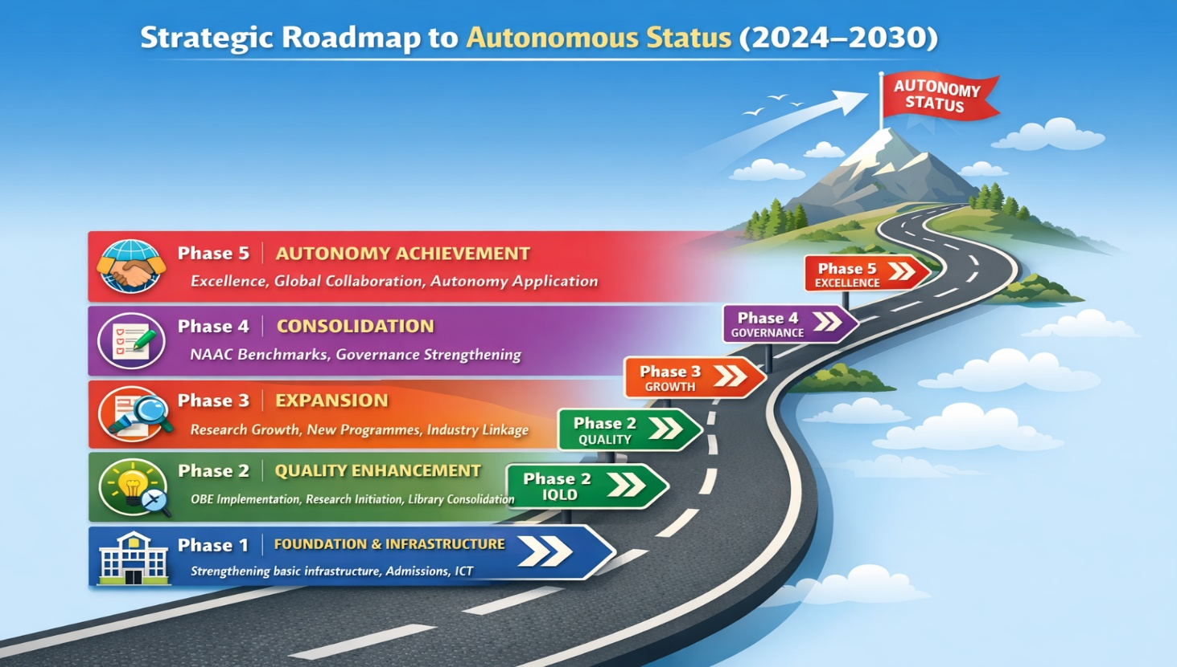
Strategic Roadmap to Autonomous Status
Phase | Timeline | Focus Area | Strategic Outcomes
Phase 1 | 2024–2025 | Foundation & Infrastructure | Strengthening basic infrastructure, admissions, ICT
Phase 2 | 2025–2026 | Quality Enhancement | OBE implementation, research initiation, library consolidation
Phase 3 | 2026–2027 | Expansion | Research growth, new programmes, industry linkage
Phase 4 | 2027–2028 | Consolidation | NAAC benchmarks, governance strengthening
Phase 5 | 2028–2030 | Autonomy Achievement | Excellence, global collaboration, autonomy application
III. ANNUAL IMPLEMENTATION PLAN (2024–2030)
Strategic Roadmap to Autonomous Status
🔷 2024–2025: Foundation & Infrastructure Phase
Focus: Infrastructure Strengthening, Admissions & Academic Support
Key Actions
- Implementation of Student Induction Programme and strengthening of the Mentor–Mentee System
- Renovation of classrooms and relocation of PG programmes to Gnanam Block
- Reconstruction and modernization of Botany & Microbiology Laboratories
- Installation of ICT tools and upgradation of the Language Laboratory
- Initiation of Faculty Research & Development Programmes and research orientation
- Launch of structured admission outreach and branding campaigns
Outcomes
- Improved classroom utilization and enhanced learning environment
- Strengthened student engagement, mentoring, and academic support systems
- Increased adoption of ICT-enabled teaching–learning practices
- Established a strong foundation for research culture and quality enhancement initiatives
🔷 2025–2026: Quality Enhancement Phase
Focus: OBE Implementation, Academic Quality, Research Initiation
Key Actions
- Achieve institution-wide OBE implementation
- Integrate NEP 2020 principles into curriculum design
- Establish Research & Innovation Cell
- Merge UG & PG libraries into a Centralized Library
- Introduce skill-based and interdisciplinary courses
- Strengthen IQAC processes and academic audits
Outcomes
- 100% adoption of Outcome-Based Education
- Enhanced curriculum relevance and academic quality
- Functional research ecosystem initiated
- Improved access to academic resources
🔷 2026–2027: Expansion Phase
Focus: Programme Expansion, Research Growth, Industry Linkages
Key Actions
Academic Expansion
- Introduce new UG, PG, and Integrated Programmes in emerging and high-demand disciplines
- Strengthen interdisciplinary, skill-oriented, and industry-relevant curriculum
Industry Linkages & Employability
- Expand and operationalize MoUs with industries and academic institutions
- Implement mandatory internships, apprenticeships, and skill certification programmes
- Strengthen career guidance, placement training, and industry–academia interaction
Research & Academic Visibility
- Promote faculty research publications, funded projects, and collaborations
- Organize National and International Conferences, Seminars, and Workshops
- Strengthen the Research & Innovation ecosystem and output
Digital & Infrastructure Development
- Upgrade classrooms to 100% ICT-enabled smart learning environments
- Enhance digital platforms, e-learning resources, and academic technologies
- Expand transport facilities and student support services
Green Campus & Sustainability
- Implement Green Campus initiatives (tree plantation, waste management, energy conservation)
- Conduct Green Audit and other environmental/sustainability audits
- Work towards achieving Green Certification and related quality benchmarks
Outcomes
- Increase in student admissions by 15–20% through programme diversification
- Significant growth in research publications and faculty engagement
- Enhanced employability through structured internships and certification programmes
- Establishment of 100% ICT-enabled teaching–learning ecosystem
- Improved student accessibility and support services (transport, facilities)
- Completion of Green Audit and progress towards environmental certifications
- Strengthened institutional visibility, academic reputation, and stakeholder confidence
🔷 2027–2028: Consolidation Phase
Focus: NAAC Benchmarking, Governance Strengthening, Quality Assurance
Key Actions
- Conduct comprehensive academic and administrative audits
- Strengthen 360° performance appraisal system
- Achieve targeted research output (40+ publications/year)
- Enhance placement training and career guidance
- Expand NSS and outreach programmes
- Implement advanced e-governance systems
Outcomes
- Alignment with NAAC quality benchmarks
- Improved institutional governance and transparency
- Strengthened student progression and placement outcomes
- Increased community engagement and social responsibility
🔷 2028–2030: Autonomy Achievement Phase
Focus: Excellence, Global Collaboration, Institutional Autonomy
Key Actions
- Apply for Autonomous Status
- Strengthen global collaborations and academic partnerships
- Achieve Green Campus Certification
- Ensure 100% internship participation and high placement rates
- Promote innovation, startups, and entrepreneurship (EDISC)
- Enhance institutional branding and national visibility
Outcomes
- Successful attainment of Autonomous Status
- Recognition as a center of academic excellence and innovation
- Sustainable institutional growth and global academic engagement
- High student success, employability, and research impact
Outcome Progression Summary (2024–2030)
- Strong infrastructure and academic foundation (2024–25)
- Quality assurance and OBE institutionalization (2025–26)
- Expansion in programmes, research, and industry linkages (2026–27)
- Consolidation with NAAC benchmarks and governance excellence (2027–28)
- Achievement of autonomy and global positioning (2028–30)
This phased Annual Implementation Plan ensures a systematic, measurable, and outcome-driven transformation, aligning institutional growth with NAAC quality benchmarks and paving a clear pathway toward Autonomous Status by 2029–2030.
IV. KPI-BASED PROGRESS TRACKING (SUMMARY)
Area | Target by 2027–2028
Admissions Growth | +20%
Pass Percentage | ≥90%
Dropout Rate | <5%
Research Publications | ≥40–50/year
MoUs | ≥20 Active
Internship Coverage | 100%
ICT Classrooms | 100%
Green Initiatives | Certification Achieved

V. IMPLEMENTATION & MONITORING MECHANISM
Execution Structure
• Governing Body → Policy Approval
• CDC → Strategic Planning
• IQAC → Monitoring & Quality Control
• Departments → Execution
Monitoring Tools
• Quarterly Reviews
• KPI Dashboard Tracking
• Feedback Analysis
• Academic & Administrative Audits
Conclusion (Roadmap Statement)
This phased roadmap (2024–2030) ensures a systematic transition from foundational strengthening to institutional excellence, enabling St. Ann’s College to achieve Autonomous Status through measurable, transparent, and quality-driven strategic implementation.
